Project Report
On

“SALE AND MARKETING DATA ANALYSIS USING TABLEAU “
by
Miss. XXXXX XXXXXX
“Your Course Name”
APPENDIX - I
CERTIFICATE FROM THE GUIDE

This is to certify that the Project work titled Sales and Marketing Data Analysis using Tableau Is a bonafide work carried out by Miss. “Your Name” Roll # 00000000 a candidate for the B.Com examination of the Institute of Management under my guidance and direction

SIGNATURE OF GUIDE
NAME XXXXX XXXXXX
DESIGNATION: Manager, Projects & Logistics
ADDRESS Maersk Line, C.G.House,
Mumbai
DATE: 20-03-2021
PLACE: Mangalore
Table of Contents
CHAPTER |  | DESCRIPTION | PAGE NO
1 |  | INTRODUCTION TO ONLINE WORLD WIDE BUSINESS
 | 1.1 | BUSINESS TO CONSUMER (B2C)
 | 1.2 | BUSINESS TO BUSINESS (B2B)
 | 1.3 | BUSINESS TO ADMINISTRATOR (B2A)
2. |  | INTRODUCTION TO BUSINESS ANALYSIS TOOL TABLEAU
 | 2.1 | WHY BUSINESS INTELLIGENCE IS IMPORTANT
 | 2.2 | HOW BUSINESS INTELLIGENCE WORK
 | 2.3 | THE FUTURE ROLE OF BUSINESS INTELLIGENCE
3 |  | THE HYPER GROWTH OF DIGITAL ECONOMY
 | 3.1 | MARKET REPORTS AND INFORMATION ON THE CONSUMER ONLINE INDUSTRY
 | 3.2 | TALKING ABOUT E GENERATION
4 |  | RESEARCH METHODOLOGY
5 |  | BUSINESS INTELLIGENCE MODEL
 | 5.1 | CATEGORY AND DEPARTMENT
 | 5.2 | SALES AND PROFIT
 | 5.3 | SALES BY REGION
 | 5.4 | PROFIT FORECASTING
 | 5.5 | TREND LINE ANALYSIS
6 |  | TABLEAU DASHBOARD
 | 6.1 | CREATING DASHBOARD
7 |  | EXPERT COMMENTS
 |  | BIBLIOGRAPHY
LIST OF FIGURES

SL No | NAME OF THE FIGURE | PAGE No
2.2 | The Modern Analytics Workflow
3.2 | Buy – Side Vs Sell - Side
5.1 | CATEGORY AND SALES
5.2 | SALES AND PROFIT BY CATEGORY
5.3 | SALES BY REGION
5.4 | PROFIT FORECASTING
5.5 | TREND LINE ANALYSIS
6.1 | Creating Worksheet
6.1.1 | Creating Multiple Worksheet
6.1.2 | Black Dashboard Sheet
6.1.3 | Combining Multiple Worksheet
6.1.4 | Sales Dashboard

CHAPTER – 1
INTRODUCTION TO ONLINE WORLD WIDE BUSINESS
The online world wide business, also known as the Web based business, is the most popular way to trawl through the information content of the Internet, the network of networks which has become part of everyday life for millions of people in all sectors of the community.
The concept of the online world wide business began in March 1989 and was developed by Tim Berners-Lee of the European Particle Physics Laboratory (CERN). He proposed the project as an effective means of transporting research and ideas throughout the organization.

The initial project proposal outlined a simple system of using a concept called “networked hypertext” to transmit documents and to communicate among staff in the high-energy physics community. Hypertext is the organization of information into connected associations that a user can choose to make. An instance of such an association is called a link or hypertext link. The Web is just a vast amount of information content connected by similar and large number of hypertext links.
This allows movement between documents or information on the same Web site or between Web sites, providing a dynamic way of accessing information.
Through the early 1990s the concept was taken on board by computer developers and hundreds of people across the world contributed by writing Web software and documents, or educating others about the Web.
- By 1994 the Web was becoming recognized across the globe and the first International World Wide Web conference was held at CERN;
- Throughout 1994, Web success stories were published by the media;
By the end of 1994, the Web had 10,000 servers, of which 2,000 were commercial, and 10 million users;
- By February 1997 the number of users had reached 57 million world-wide;
- By November 2000 there was a staggering 407 million users world-wide.
The Web today is a vast resource of information of all types, accessed and used by all sections of society, from research institutions and public and private sector organizations, to all sectors of the business community, as well as private individuals.
Very little of today’s world is not represented on the World Wide Web.
The use of the Web seems almost limitless. Every day people discover exciting new ways to use the development. Some use it to publish information about their company or hobbies whilst, increasingly, it is used to conduct business. Companies are being set up which rely totally on the Web as a delivery mechanism and are frequently referred to as Dot.Coms. The ONLINE WORLD WIDE BUSINESS is the interactive, graphical portion of the Internet, reflecting the fact that the millions of documents or pages of information stored on many computers found throughout the world, may contain text, images, sound and movie clips.
The computers that store Web documents are called Web servers. They run special software that lets you connect to the Web server and view the stored documents.
The considerable hype surrounding eCommerce could lead many Small Enterprises (SMEs) to believe that they are lagging behind if they are not part of the new trading revolution. Much of the hype relates to success stories about Internet selling, but SMEs should know that other types of e-Business relationships exist which can bring their own benefits.

1.1 : Business-to-Consumer (B2C)
Where much of the initial success was generated as companies sold selected consumer products to an Internet-literate audience, willing to buy on-line. SMEs can still succeed in this area without an on-line selling capacity simply by improving the marketing of their products to potential customers.

1.2 : Business-to-Business (B2B)
Interaction between businesses, either in an established supply chain or with new trading partners. An area which didn’t get as much publicity as the Business to Consumer activities but one which is now gaining more recognition because it is far more important to most small businesses, especially in the manufacturing sector.

1.3 : Business-to-Administration (B2A)
A third category of eCommerce, still in the early stages of development, is in which the business community interacts electronically with public sector organizations. Submission of planning applications, VAT returns, income tax, or patent registration, all come within this category and B2A applications have the potential to bring even more companies into the world of electronic trading.

CHAPTER – 2
INTRODUCTION TO BUSINESS ANALYSIS TOOL TABLEAU

Business intelligence (BI) combines business analytics, data mining, data visualization, data tools and infrastructure, and best practices to help organizations to make more data-driven decisions. In practice, you know you’ve got modern business intelligence when you have a comprehensive view of your organization’s data and use that data to drive change, eliminate inefficiencies, and quickly adapt to market or supply changes.
It’s important to note that this is a very modern definition of BI—and BI has had a strangled history as a buzzword. Traditional Business Intelligence, capital letters and all, originally emerged in the 1960s as a system of sharing information across organizations. It further developed in the 1980s alongside computer models for decision-making and turning data into insights before becoming specific offering from BI teams with IT-reliant service solutions. Modern BI solutions prioritize flexible self-service analysis, governed data on trusted platforms, empowered business users, and speed to insight.
Much more than a specific “thing,” business intelligence is rather an umbrella term that covers the processes and methods of collecting, storing, and analyzing data from business operations or activities to optimize performance. All of these things come together to create a comprehensive view of a business to help people make better, actionable decisions.
Over the past few years, business intelligence has evolved to include more processes and activities to help improve performance. These processes include:
- Data mining: Using databases, statistics and machine learning to uncover trends in large datasets.
- Reporting: Sharing data analysis to stakeholders so they can draw conclusions and make decisions.
- Performance metrics and benchmarking: Comparing current performance data to historical data to track performance against goals, typically using customized dashboards.
- Descriptive analytics: Using preliminary data analysis to find out what happened.
- Querying: Asking the data specific questions, BI pulling the answers from the datasets.
- Statistical analysis: Taking the results from descriptive analytics and further exploring the data using statistics such as how this trend happened and why.
- Data visualization: Turning data analysis into visual representations such as charts, graphs, and histograms to more easily consume data.
- Visual analysis: Exploring data through visual storytelling to communicate insights on the fly and stay in the flow of analysis.
- Data preparation: Compiling multiple data sources, identifying the dimensions and measurements, preparing it for data analysis.

2.1 : WHY IS BUSINESS INTELLIGENCE IMPORTANT
Business intelligence can help companies make better decisions by showing present and historical data within their business context. Analysts can leverage BI to provide performance and competitor benchmarks to make the organization run smoother and more efficiently. Analysts can also more easily spot market trends to increase sales or revenue. Used effectively, the right data can help with anything from compliance to hiring efforts.
A few ways that business intelligence can help companies make smarter, data-driven decisions:
- Identify ways to increase profit.
- Analyze customer behavior.
- Compare data with competitors.
- Track performance.
- Optimize operations.
- Predict success.
- Spot market trends.
- Discover issues or problems.

2.2 : HOW BUSINESS INTELLIGENCE WORK
Businesses and organizations have questions and goals. To answer these questions and track performance against these goals, they gather the necessary data, analyze it, and determine which actions to take to reach their goals. On the technical side, raw data is collected from the business’s activity. Data is processed and then stored in data warehouses. Once it’s stored, users can then access the data, starting the analysis process to answer business questions.
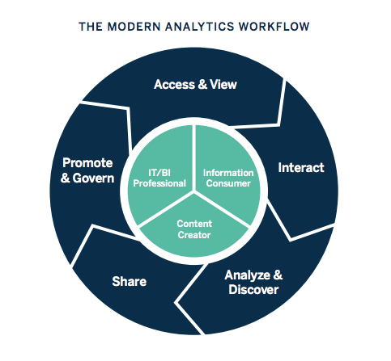
Fig No. 2.2 : The Modern Analytics Workflow
Business intelligence includes data analytics and business analytics, but uses them only as parts of the whole process. BI helps users draw conclusions from data analysis. Data scientists dig into the specifics of data, using advanced statistics and predictive analytics to discover patterns and forecast future patterns. Data analytics asks “Why did this happen and what can happen next?” Business intelligence takes those models and algorithms and breaks the results down into actionable language.
2.3 : THE FUTURE ROLE OF BUSINESS INTELLIGENCE
Business intelligence is continually evolving according to business needs and technology, so each year, we identify current trends to keep users up-to-date on innovations. Realize that artificial intelligence and machine learning will continue to grow, and businesses can integrate the insights from AI into a broader BI strategy. As companies strive to be more data-driven, efforts to share data, and collaborate will increase. Data visualization will be even more essential to work together across teams and departments.
This article is just an introduction to the world of business intelligence. BI offers capabilities for near real-time sales tracking, allows users to discover insights into customer behavior, forecast profits, and more. Diverse industries like retail, insurance, and oil have adopted BI and more are joining each year. BI platforms adapt to new technology and the innovation of its users. Stay up-to-date with all of the trends and changes in business intelligence as we list the top 10 current trends in BI.

CHAPTER – 3
The hyper growth of digital economy
While estimates vary widely:
- Retailing on the Internet accounted for less than 3% of total North American retail sales in 1998. Growth rates, however, have been very encouraging. It was estimated that in the year 2000 business-to-consumer Internet transactions worldwide has amounted to approximately $20-$50 billion, while business-to-business transactions has reached in the $50-$150 billion range.” (Industry Canada)
- Internet traffic is doubling every 100 days. Digital economy is doubling annually. Worldwide e-business was exceeded $1 trillion by 2002.(a survey)
- Canada is the most ‘wired’ nation, with the highest per capita rate of Internet-connected people. Forty-five percent of Canadians are online for a total of 13.5 million users. Americans rank first for the total number of users with 92 million people online, or 34 percent of the population. (NUA Internet Surveys, 1999)
- 61% of Canadian small and medium-sized enterprises (SME5) were connected to the Internet in 1999. (Internet Institute)
- Canada has the lowest Internet access cost in the world. (OECD, 1997)

3.1 : MARKET REPORTS AND INFORMATION ON THE CONSUMER ONLINE INDUSTRY:
- NUA Internet Surveys
- International Communications Inc.
- Jupiter Communications
- COM QUEST Research (Canadian data)
NEWS AND ANALYSIS.
China’s Mr. Internet: Jack Ma wants to build China’s first genuinely global Digital Economy firm - The Economist (Aug 26, 2000)
- Thinking Strategically about Selling Online - Ascenda
Home Internet use ‘growing’ - BBC News (Aug 7, 2000)
- Dairy industry turns to Digital Economy - CNN (Jul 28, 2000)
- Online shopping gets more convenient - BBC News (Jul 27, 2000)

ALL DIGITAL ECONOMY
- Digital Economy Times: getting started, strategies, news and reports.
- Focuses on buying and selling over the Internet, along with ongoing issues that will impact the future of electronic commerce.
- The Agricultural Forum (U.S.) has a series of papers on the effects of Digital Economy in the agri food industry.
- Digital Economy survey by The Economist

3.2 : TALKING’ ABOUT E-GENERATION
Student opinions report by The Economist, Most business owners understand the idea of conducting business over the Internet, and probably understand the need to “get their business online” but what is Digital Economy, really, and how do you get started?

In a nutshell, Digital Economy is a way of conducting business through computers and over networks. Simply put, Digital Economy is buying and selling over the Internet. But it’s actually much more than that. Business interactions of all types-from simple buying and selling, to complex business practices such as banking, manufacturing, and supply chain management-can be easily accomplished using the Internet along with real time data.
Buy-Side vs. Sell-Side: Digital Economy
There are two basic sides to Digital Economy; the Buy Side and the Sell Side
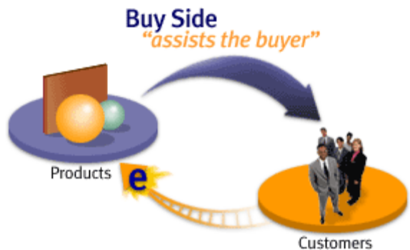
Fig No. 3.2 : Buy – Side Vs Sell - Side
Buy Side
Customers
Buy Side refers to the Digital Economy functionality that enables a business to sell their products to a buyer (customer) online. This buyer could be an individual consumer or a large company buying products for commercial use. The purpose is to make online buying easier and the experience more pleasant for the buyer. The more robust the choice in conjunction with an easier, user- friendly web site, customer satisfaction increases and so do sales.
Sell Side refers to the Digital Economy functionality that enables a company to actually make their goods and services available over the Internet. Critical to the success of the seller, it assists the seller in improving internal business processes and functionality. The purpose is to help companies increase revenue and profitability by reducing business and procurement costs. Since Digital Economy is a relatively new phenomenon, the definitions and jargon are not necessarily embedded into our everyday business lexicon.

CHAPTER – 4
RESEARCH METHODOLOGY
To determine the significance and growth of Digital Economy in International market, a survey was conducted during June, 2007. The survey questionnaire was designed on the requirements and significance of Digital Economy in India and Supply Chain Practices. The survey instrument focused on the following areas:

- Importance of Digital Economy to the organizations
- Reasons for Digital Economy implementation
- The impact of using Digital Economy on logistics performance, customer
Results
Participant profile
The responding organizations represented a broad cross-section of the industry including FMCG, Pharmacy, Consumer, Retail, Automotive and Paint industries. However majority of the respondents were from FMCG, Pharmacy and Consumer.
The respondent includes a mix of public sector as well as the private sector. The responses are markedly better from public limited company, which constituted nearly 76% of the total sample, followed by private limited 24%, 44% had MNC stake.
Satisfaction and employee morale.
- The benefits of using Digital Economy on specific business objectives;
- The overall satisfaction with Digital Economy implementation and the future plans of current users of Digital Economy services
The respondents were requested to fill out the survey that best captured the current state of organizational issue with emphasis on outsourcing. In addition to the questionnaire survey and a number of personal visits to various organizations were carried out to get firsthand information related to this field as well as cross- check on responses received from the survey participants.
The target population for this study was list of top 50 organizations in India from FMCG, Pharmacy, Consumer, Retail, Automotive, Paints etc. the questionnaire in most cases was completed during the personal meeting and the remaining with the cover letter and post-reply envelope were mailed to these organizations addressed to the executives. Within few days of sending out the survey
questionnaire 25 responses were received. Thereafter reminder telephone calls were made to the remaining organization that had not responded. Tableau allow user and organization to track all the business activities with no time and track all the business activities and all us to forecast.
Business-to-Consumer:
The arrival of the Internet and the World Wide Web (WWW) brought a new way of doing business and many of the success stories that capture the public attention are consumer- orientated. Examples are Amazon.com and Tesco’s on-line ordering system.
Business-to-Consumer (B2C) systems are those where a consumer interacts directly with the supplier’s system through their own computers. It is simply electronic retailing using the Web as a medium to place orders for typical consumer goods such as books, CDs and, increasingly, travel arrangements. SMEs can be involved in B2C eCommerce without actually selling goods, if the target audience for their services is end-consumers.
SMEs with much smaller budgets than Amazon and Tesco could typically use a third part electronic catalogue product, which would provide a mechanism for displaying items for sale and a secure mechanism for accepting orders and payments from customers. Although such systems would need integrating with other computer programs being run within a business, there are many examples of initial SME B2C systems being run as stand alone systems.
There are also examples in the Opportunity Wales Web site of companies such as Trophy Miniatures and Farmyard Nurseries, who are using the WWW as a powerful marketing tool
without actually selling their goods on-line. Their activities are still classified as B2C
eCommerce.
B2C can also relate to receiving information such as share prices, insurance quotes, on-line newspapers, or weather forecasts. The supplier may be an existing retail outlet such as a high street store; it has been this type of business that has been successful in using eCommerce to deliver services to customers. These businesses may have been slow in gearing-up for eCommerce compared to the innovative dot.com start ups, but they usually have a sound commercial structure as well as in-depth experience of running a business - something which many dot.coms lacked, causing many to fail.

Business-to-Business:
As the name suggests, B2B is the term used for eCommerce in a pure business environment. It covers the many ways that eCommerce can be used to support one business trading with another.
B2B eCommerce is being driven from two sides. At the pragmatic level are businesses looking to use technology to develop improved ways of working and relationships with trading partners up and down the supply chain. At the other end of the spectrum are the eCommerce product and service providers who are developing new ideas and concepts and hoping that some will “fly”.
Much of the attention given to B2B relates to emerging embryonic developments such as eMarketplaces and e-Exchanges, but most of the actual use of eCommerce is at a lower level in the eCommerce implementation cycle.

Typically in the B2B environment, eCommerce can be used in the following processes:
- procurement;
- order fulfillments;
- Managing trading-partner relationships.
For many SMEs B2B eCommerce is synonymous with the vision of integrated supply chains.
This might be the ultimate objective, but, in the short term, B2B eCommerce could be used as a significant enabler in their move towards greater trading partner collaboration.
E-Commerce technologies have allowed even the smallest businesses to improve the processes for interlacing with customers. They are now able to develop services for individual clients rather than provide a standard service. Pentwyn Splicers based in Pontypool manufacture pneumatic splicers for the UK and world textile market. They evaluated all aspects of their business process to determine where the greatest return could be obtained. Using the Web to sell more products was an initial consideration, but it was in the provision of customer service and support to their overseas distributors that the greatest benefits have been achieved.

An alternative way of thinking of B2B eCommerce is to think of it as being used to:

- Attract, develop, retain, and cultivate relationships with customers;
- Streamline the supply chain, manufacturing, and procurement processes, and automate corporate processes to deliver the right products and services to customers quickly and cost-effectively;
- Capture, analyse, and share, information about customers and company operations, in order to make better decisions.

Business-to-Administration:
B2A is the least developed area of eCommerce and it relates to the way that public sector organisations, at both a central and local level, are providing their services on-line. Also known as e-Government, it has the potential to increase the domestic and business use of eCommerce as traditional services are increasingly being delivered over the Internet.
The UK government is committed to ensuring this country is at the forefront of eCommerce and it is essential that e-Government plays a significant part in achieving this objective.
Four guiding principles underlie the UK strategy for e-Government. These are:

- Building services around citizens’ choices;
- Making government and its services more accessible;
- Ensuring that new technology does not create a digital divide between those with ready access to electronic media and those without;
- Using information more effectively.
Central government was leading the way with the overall aim of having 100% of services on-line by 2005. 80% of councils in England now have public email and Internet access, with 33% of authorities having at least three services accessible in this form. Many councils are now developing their own eCommerce strategies, but few have a fully integrated approach expected of corresponding-sized organisations in the business world. Andrew Davies, e-Minister for Wales, is developing a strategy for e-Government, but few Authorities appear at the forefront of developments.

CHAPTER – 5
BUSINESS INTELLIGENCE MODEL
The term business model refers to a company's plan for making a profit. It identifies the products or services the business plans to sell, its identified target market, and any anticipated expenses. Business models are important for both new and established businesses. They help new, developing companies attract investment, recruit talent, and motivate management and staff. Established businesses should regularly update their business plans or they'll fail to anticipate trends and challenges ahead. Business plans help investors evaluate companies that interest them. A business model is a high-level plan for profitably operating a business in a specific marketplace. A primary component of the business model is the value proposition. This is a description of the goods or services that a company offers and why they are desirable to customers or clients, ideally stated in a way that differentiates the product or service from its competitors.
In our Project, we have considered following business model, such as
- Category and Department
- Sales and Profit
- Sales by Region
- Profit Forecast
- Trend Lines of the Business.

5.1 : CATEGORY AND DEPARTMENT

How often are sellers making decisions based on intuition or gut feeling? Sales dashboards present relevant and actionable sales data, allowing sellers to make data-driven decisions quickly. Having the right sales dashboards based on current data leads to time savings: sellers can be hyper focused on which leads need contacting that day, how close they are to hitting their quota, what talking points to use in a call, and more. In this article, we'll share with you why sales dashboards are necessary to effective sales strategy, how to begin building effective dashboards people will use, and share seven examples to inspire.
We have filter sales growth data by region, segment, salesperson account with this dashboard and view YOY comparisons by selecting the filters you want in the top, dropdown menu labeled, "Select how to slice results." The most effective use of this sales growth dashboard will come from the context it provides, helping managers to identify patterns or trends, set realistic goals, and nurture sellers. For example, seeing the status of deals by representative means that you can help sellers change tactics and avoid leaving money on the table. These actionable insights can re-engage discouraged sellers, focus your team on customer success, and reduce uncertainty in planning.
- Intended audience: This pipeline dashboard is meant for sales executives, managers, and sales analysts.
- Focus metrics: Amplified booking percentage, all of the filters on how to slice results in various ways, see the data by account-level, and account details.
- When to use: Use this dashboard when setting sales goals to gain context around who reps are selling to, how reps are selling (eg. inside, field), and products they're selling, and where.
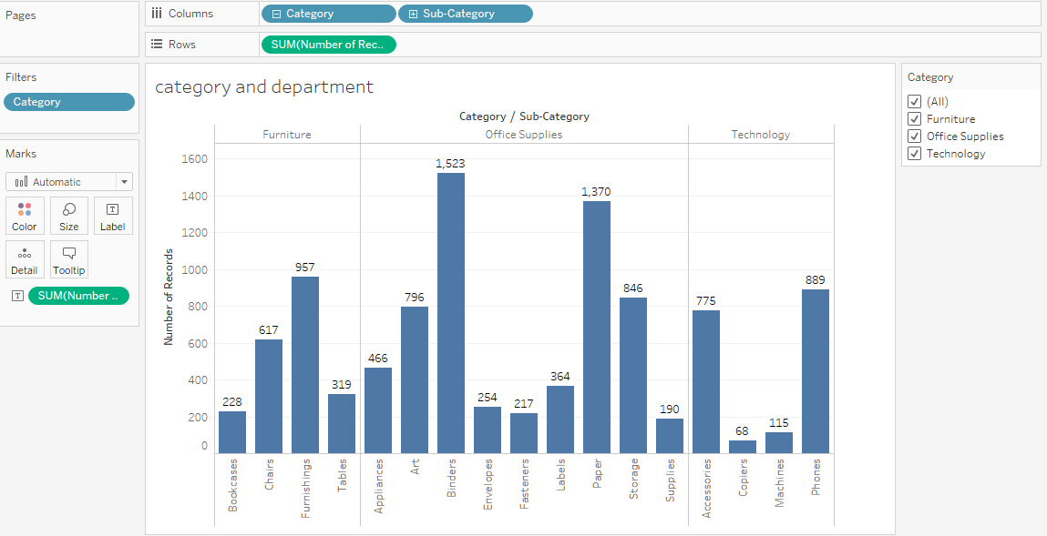
Fig No : 5.1 : CATEGORY AND SALES
In the creation and assignment of sales territories, having a proactive approach can improve seller performance. We have found that optimizing territory design can increase sales from two to seven percent without changes in resources. You need the data to understand the sales KPIs impacting your territories to better balance workloads across the field and easily see unworked opportunities.

5.2: SALES AND PROFIT
Our Tableau dashboard comprised of the aforementioned charts. This interactive dashboard enables the consumer to understand sales information by trend, region, profit and top products. Using actions in place of Quick Filters provides a number of benefits. First, the dashboard will load more quickly. Using too many Quick Filters or trying to filter a very large dimension set can slow the load time because Tableau must scan the data to build the filters. The more quick filters enabled on the dashboard, the longer it will take the dashboard to load. By creating a series of four-panel, four cascading dashboards the load speed was improved dramatically and the understandability of the information presented was greatly enhanced. The top-level dashboard provided a summary view, but included filter actions in each of the visualizations that allowed the executive to see data for different regions, products, and sales teams.
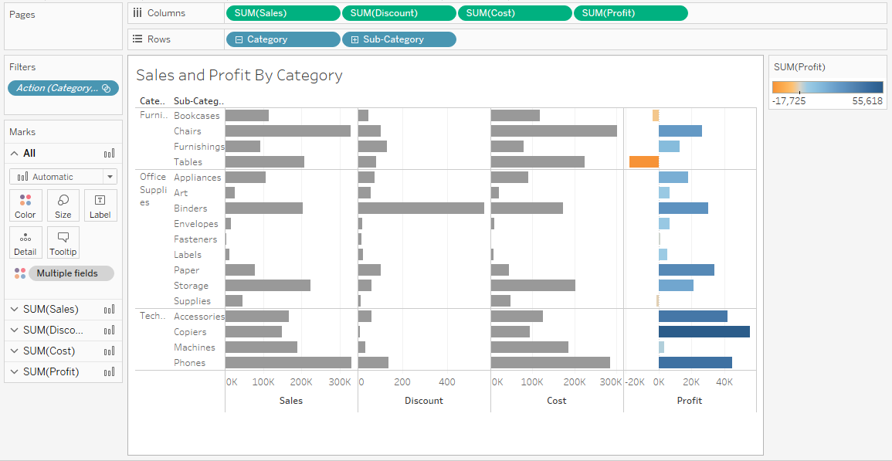
FIG NO. 5.2 : SALES AND PROFIT BY CATEGORY
A key feature of sales dashboards in Tableau is interactivity. Dashboards are not simply a set of reports on a page; they should tell a story about the business. In order to facilitate the decision-making process, interactivity is an important part of assisting the decision-maker to get to the heart of the analysis as quickly as possible. This Dashboard, made on Tableau, visualizes the Sales and Profit Analysis of a Supermarket.
At a glance, you can see:
- The Sales distribution of various categories relative to each other
- Their respective Profit margins.
- Each Category’s Sub – Category Product Sales
- And finally, the Sales growth of Categories over the years
5.3 : SALES BY REGION
We have built a great view that allows you to review sales and profits by product over several years. And after looking at product sales and profitability in the South, you decide to look for trends or patterns in that region. Since we are looking at geographic data (the Region field), you have the option to build a map view. Map views are great for displaying and analyzing this kind of information. Tableau has already assigned the proper geographic roles to the Country, State, City, and Postal Code fields. That's because it recognized that each of those fields contained geographic data. You can get to work creating your map view right away.
Since Tableau already knows that state names are geographic data, and because the State dimension is assigned the State/Province geographic role, Tableau automatically creates a map view. There is a mark for each of the 48 contiguous states in your data source. (Sadly, Alaska and Hawaii are not included in your data source, so they are left out.)
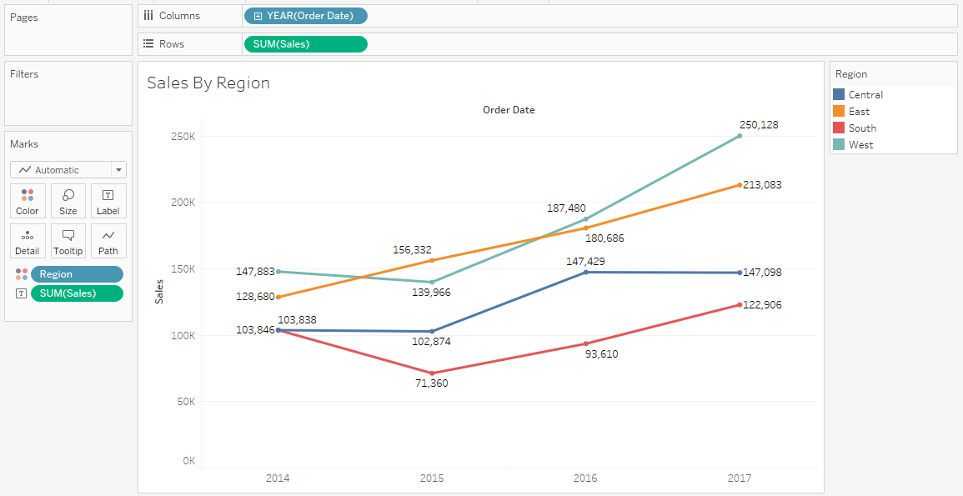
FIG NO. 5.3 : SALES BY REGION
Notice that the Country field is also added to the view. This happens because the geographic fields in Sample - Superstore are part of a hierarchy. Each level in the hierarchy is added as a level of detail, like layers of an onion. Additionally, Latitude and Longitude fields are added to the Columns and Rows shelves. You can think of these as X and Y fields. They're essential any time you want to create a map view, because each location in your data is assigned a latitudinal and longitudinal value. Sometimes the Latitude and Longitude fields are generated by Tableau. Other times, you might have to manually include them in your data. You can find resources to learn more about this in the Learning Library. Now, having a cool map focused on 48 states is one thing, but you wanted to see what was happening in the South.
5.4 : PROFIT FORECASTING
For forecasting, we are going to deal with the Sales and Profit Growth chart. The construction is similar to that of Trend Lines, but with a small change. The steps are :
- Drag Forecast over the chart.
- You can also change the time frame of the Forecast, by right-clicking on the Forecast Area and opting for Forecast Options, after which you can make your customizations:
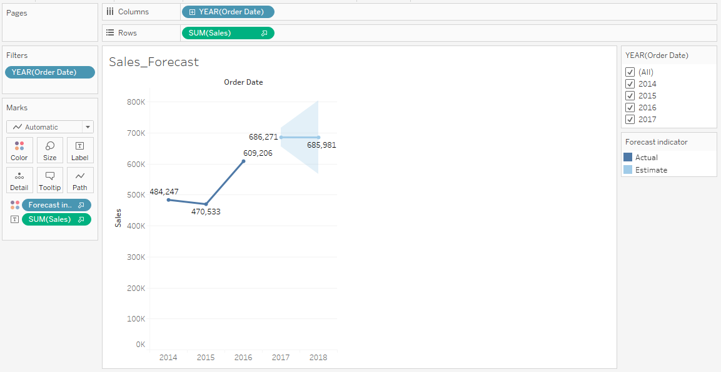
Fig No. 5.4 : PROFIT FORECASTING
Each of the following examples indicate the structure that supports creating a forecast.
- The field you want to forecast is on the Rows shelf and a continuous date field is on the Columns shelf.
- The field you want to forecast is on the Columns shelf and a continuous date field is on the Rows shelf.
- The field you want to forecast on either the Rows or Columns shelf, and discrete dates are on either the Rows or Columns shelf. At least one of the included date levels must be Year.
- The field you want to forecast is on the Marks card, and a continuous date or discrete date set is on Rows, Columns or Marks.
5.5 : TREND LINE ANALYSIS
Traverse back to the Peak Sales and Profit Month Chart and follow these steps to make a Trend Line of your own:
- Go to Show Me and choose the Dual Combination chart, to get this chart.
- To get the Trend Line, go to Analytics, and simply drag Trend Line over the chart, to get.
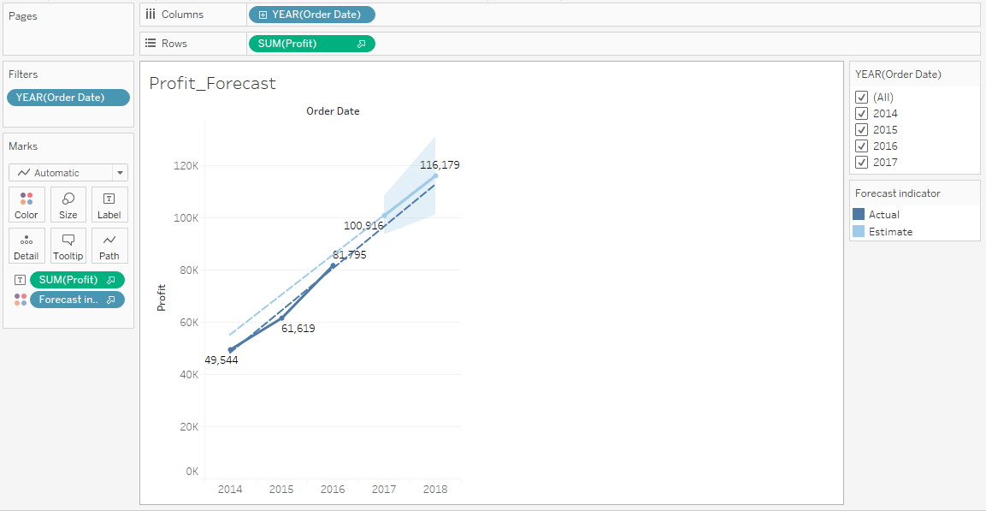
Fig No. 5.5 : TREND LINE ANALYSIS
To add trend lines to a view, both axes must contain a field that can be interpreted as a number. For example, you cannot add a trend line to a view that has the Product Category dimension, which contains strings, on the Columns shelf and the Profit measure on the Rows shelf. However, you can add a trend line to a view of sales over time because both sales and time can be interpreted as numeric values.
For multidimensional data sources, the date hierarchies actually contain strings rather than numbers. Therefore, trend lines are not allowed. Additionally, the ‘m/d/yy’ and ‘mmmm yyyy’ date formats on all data sources do not allow trend lines.
If you have trend lines turned on and you modify the view in a way where trend lines are not allowed, the trend lines do not show. When you change the view back to a state that allows trend lines, they reappear.
You can configure the following options in the Trend Line Options dialog box:
- Select a model type. For more information, see Trend Line Model Types.
- Select which fields to use a factors in the trend line model. For more information, see Choose which fields to use as factors in the trend line model.
- Decide whether to exclude color, using the Allow a trend line per color option. When you have color encodings in your view, you can use this option to add a single trend line that models all of the data, ignoring the color encoding.
- Decide whether to Show Confidence Bands. Tableau confidence bands show upper and lower 95% confidence lines by default when you add trend lines. Confidence lines are not supported for Exponential models.
- Select whether to Force the y-intercept to zero. This option is useful when you know that you want your trend line to begin at zero. This option is available only when both the Rows shelf and the Columns shelf contain a continuous field, as with a scatterplot.
- Decide whether to show recalculated lines when you select or highlight data in the visualization.

CHAPTER – 6
TABLEAU DASHBOARD
A dashboard is a consolidated display of many worksheets and related information in a single place. It is used to compare and monitor a variety of data simultaneously. The different data views are displayed all at once. Dashboards are shown as tabs at the bottom of the workbook and they usually get updated with the most recent data from the data source. While creating a dashboard, you can add views from any worksheet in the workbook along with many supporting objects such as text areas, web pages, and images.
Each view you add to the dashboard is connected to its corresponding worksheet. So when you modify the worksheet, the dashboard is updated and when you modify the view in the dashboard, the worksheet is updated.
6.1 : CREATING DASHBOARD
Using the Sample-superstore, plan to create a dashboard showing the sales and profits for different segments and Sub-Category of products across all the states. To achieve this objective, following are the steps.
Step 1 − Create a blank worksheet by using the add worksheet icon located at the bottom of the workbook. Drag the dimension Segment to the columns shelf and the dimension Sub-Category to the Rows Shelf. Drag and drop the measure Sales to the Color shelf and the measure Profit to the Size shelf. This worksheet is referred as the Master worksheet. Right-click and rename this worksheet as Sales_Profits. The following chart appears.
Tableau uses a workbook and sheet file structure, much like Microsoft Excel. A workbook contains sheets. A sheet can be a worksheet, a dashboard, or a story. A dashboard is a collection of views from multiple worksheets. A dashboard is a collection of views from multiple worksheets. The Dashboard and Layout panes are available in its side bar. For more details about creating dashboards, see Dashboards. A worksheet contains a single view along with shelves, cards, legends, and the Data and Analytics panes in its side bar. For details on the worksheet workspace, see The Tableau Workspace.
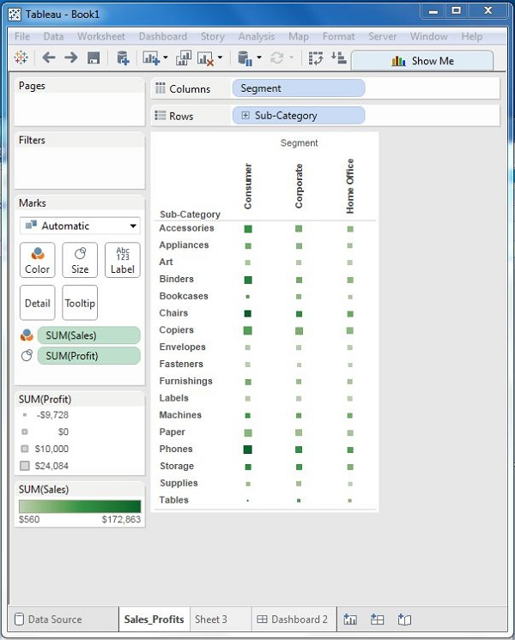
Fig No. 6.1 : Creating Worksheet
Step 2 − Create another sheet to hold the details of the Sales across the States. For this, drag the dimension State to the Rows shelf and the measure Sales to the Columns shelf as shown in the following screenshot. Next, apply a filter to the State field to arrange the Sales in a descending order. Right-click and rename this worksheet as Sales_state.
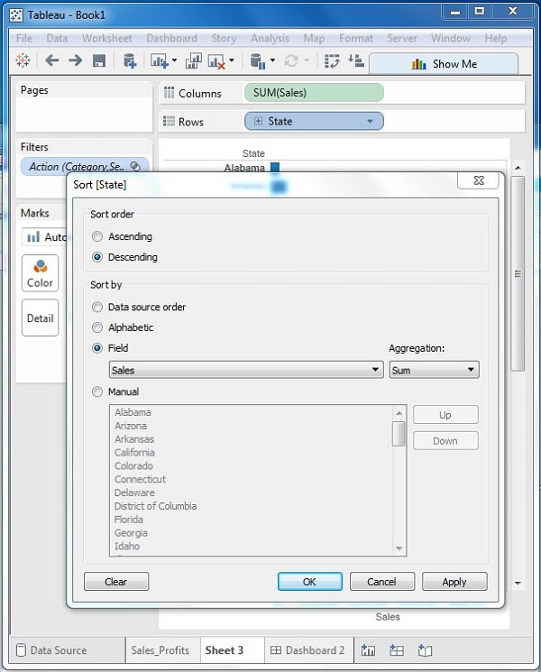
Fig No. 6.1.1 : Creating Multiple Sheet
Step 3 − Next, create a blank dashboard by clicking the Create New Dashboard link at the bottom of the workbook. Right-click and rename the dashboard as Profit_Dashboard.
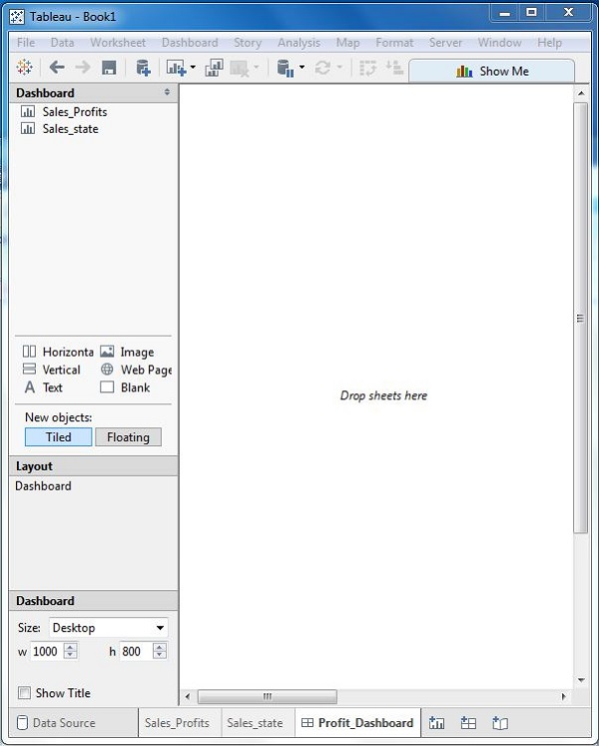
Fig No. 6.1.2 : Black Dashboard Sheet
Step 4 − Drag the two worksheets to the dashboard. Near the top border line of Sales Profit worksheet, you can see three small icons. Click the middle one, which shows the prompt Use as Filter on hovering the mouse over it.
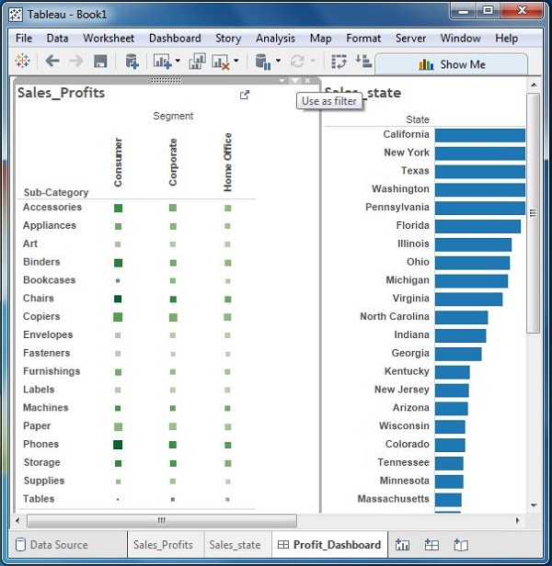
Fig No. 6.1.4 : Combining Multiple Worksheet
Step 5 − Now in the dashboard, click the box representing Sub-Category named Machines and segment named Consumer. You can notice that only the states where the sales happened for this amount of profit are filtered out in the right pane named Sales_state. This illustrates how the sheets are linked in a dashboard.
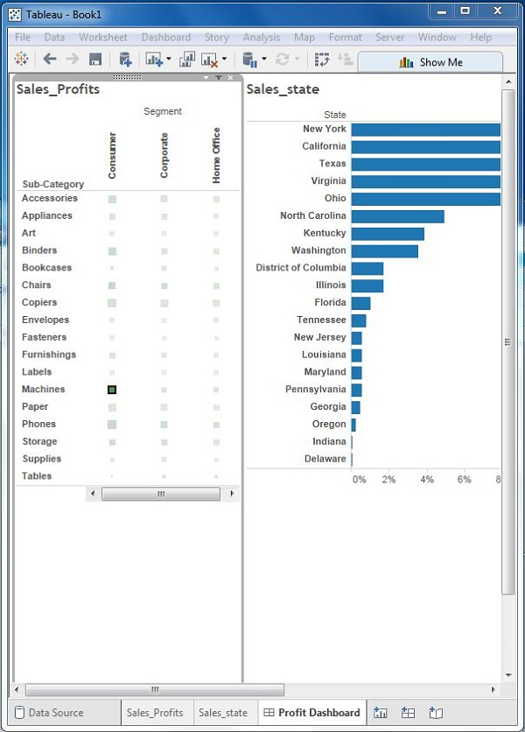
Fig No. 6.1.5 : Sales Dashboard
CHAPTER – 7

Expert Comments

Tableau Data Analysis tool should create confidence in their customer by considerable investment in business, they hire services from other service providers instead of this they should go for collaborations and that too with good companies. who are
number br 2 in their respective sector, if you hire services of number 4-5 in that
sector Quality and Overall Efficiency goes down. More importantly, a Tableau service
provider should understand the company’s business first, then should create a
flexible environment for their customer and should allow two way interactions.
Particularly, in the business of Pharmaceuticals, Tableau service provider must be
made is mind to face the hassles in Licensing, Drug Regulation Acts, Authorized
Signatory, etc.

Tableau players must understand that they provide Place utility, out of 4 P’s of the
business utilities, so they should consider it as prime focus to provide the Place
Utility to their customers. As far as pricing is concerned, they should consider an overall Profitability in the business instead of trying to generate profit at each link of the chain.
In literal sense, 3 PL must act as a Shadow of their customer without any self-policies, even with flexible IT systems.

Mr. Mohammed Tanzeem Agra
CEO – XERXEZ SOLUTIONS

Bibliography
SL No | RESOURCES
1. | http://www.perceptualedge.com/library.php#Books
2. | http://shop.oreilly.com/product/0636920000617.do
3. | https://freakalytics.com/blog/2013/10/09/practical-analytics-podcast-pick-up-your-early-preview-copy-of-the-accidental-analyst/
4. | http://www.thefunctionalart.com/p/about-book.html
5. | https://www.edwardtufte.com/tufte/books_vdqi
6. | https://www.amazon.com/Cartographies-Time-A-History-Timeline/dp/1616890584
7. | https://www.amazon.com/Information-Graphics-Sandra-Rendgen/dp/3836528797
8. | https://ccom.unh.edu/vislab/index.html
9. | http://www.storytellingwithdata.com/book/
10. | https://informationisbeautiful.net/books/

